**SALES ANALYSIS Dashboard-Supporting Document**

**Project Overview**

The **SALES ANALYSIS** project offers valuable insights into the performance of sales across various regions, teams, and products. It leverages advanced data cleaning, transformation techniques, and calculated measures to provide a comprehensive view of key performance indicators (KPIs). These include monthly sales, shipments, profitability, and more, helping organizations make data-driven decisions and optimize their sales strategies.

**Data Cleaning and Transformation Process**

Data cleaning and transformation were integral steps in preparing the raw sales data for analysis. Below are the processes applied to ensure high-quality, accurate data:

1. **Date Manipulation**:
   * Extracted and created several time-based columns to facilitate time-series analysis.
     + **Added Columns**: Year, Month, Month Name, Day of Week, Day Name, and Start of Month.
   * These new time columns provided the foundation for tracking sales, shipment, and profitability trends over time.
2. **Cost Column**:
   * Added a **Cost** column to enable calculations related to profit and cost analysis.
   * This column facilitated more accurate profitability and cost performance insights.

This transformation phase ensured the dataset was well-structured and ready for advanced analysis in the dashboard.

**Measures Created**

Several calculated measures were created to enhance the analytical capabilities of the dashboard. These measures are designed to allow in-depth performance analysis over time and across multiple dimensions, such as region, salesperson, and product. The measures include:

1. **Latest Date**:
   * Identifies the most recent date available in the dataset, used for reference in various time-based analyses.
2. **Change Metrics** (Month-over-Month % Changes):  
   These metrics track the percentage change in key performance indicators (KPIs) between months:
   * **latest MoM sales %**: Measures month-over-month change in sales.
   * **LBS%**: Latest month’s box shipment percentage change.
   * **MoM box change %**: Month-over-month change in box quantities shipped.
   * **MoM cost change %**: Month-over-month change in total cost.
   * **MoM profit change %**: Month-over-month change in profit.
   * **MoM sales change %**: Month-over-month change in sales.
   * **MoM shipment change %**: Month-over-month change in shipment numbers.
3. **Profitability Targets**:  
   These measures help assess whether profitability targets were met:
   * **profit target**: The desired profitability set as a target.
   * **profit target indicator**: A visual measure indicating whether the profitability target was met.
   * **profit %**: Calculates the profit as a percentage of sales.
4. **Cumulative Totals**:  
   These measures provide cumulative figures for tracking sales performance over time:
   * **total boxes**: Total number of boxes shipped.
   * **total cost**: Total cost incurred.
   * **total profit**: Total profit earned.
   * **total sales**: Total sales revenue generated.
   * **total sales (prev)**: Total sales from the previous period.
   * **total sales (latest month)**: Total sales for the most recent month.
   * **total shipment**: Total number of shipments made.
5. **Measure Selector**:
   * A dynamic selector used to toggle between different measures, providing flexible analysis for end-users.

These custom measures significantly enhanced the dashboard's analytical depth, providing dynamic insights into key business metrics.

**Initial Dataset Columns and Structure**

The dataset used for this analysis contained several key columns that formed the backbone of the analysis:

* **Calendar Information**:
  + calendar[date]: The core date field used for time-series analysis.
* **Location Data**:
  + location[geo, region]: Geographical information such as country and regional data for analyzing location-based sales performance.
* **Sales Team Information**:
  + people[picture, salesperson, team]: Data related to the sales team, including salesperson names and associated teams.
* **Product Details**:
  + product[category, cost per box, product]: Information related to the products sold, including their category and cost per unit.
* **Shipment Details**:
  + shipment[boxes, date, geography, product, sales, salesperson]: Data on each shipment made, including the number of boxes, geographical region, product details, and the salesperson responsible.

These columns provided the essential data structure needed to perform in-depth analysis on sales, shipments, and profitability across multiple dimensions.

**Dashboard Overview**

The **SALES ANALYSIS** dashboard offers a user-friendly interface with multiple tabs and dynamic visualizations, enabling quick access to key insights. Below are the major sections and visual components included in the dashboard:

**1. Sales Summary:**

* Displays total values for critical KPIs such as:
  + **Total Sales**
  + **Total Costs**
  + **Total Shipments**
  + **Total Boxes**
  + **Total Profit**
* Showcases key **month-over-month (MoM) percentage changes** and the **latest LBS%**.

**2. Profit Analysis:**

* **Profit by Start of Month**: A line chart visualizing monthly profit trends over the last several months.
* **Profit % and LBS% by Salesperson**: A ranked list of salespeople, along with indicators for their **profit percentage** and **LBS%** performance.
* **Profit by Geography Tooltip**: A tooltip feature displaying specific profit details by geographic region for deeper regional profitability insights.

**3. Shipment Analysis:**

* **Shipment Trends**: A bar chart illustrating monthly shipment volumes and changes over time, providing insights into shipment performance.

**4. Filters:**

* Filters allow for customized views of the data, enabling users to filter by:
  + **Regions**
  + **Product Categories**
  + **Sales Teams**
* These filters enhance the dashboard’s flexibility and allow users to focus on specific areas of interest.

**Screenshots**

Below are some screenshots illustrating key components of the dashboard:

1. **Sales Summary**
2. **Profit Analysis**
3. **Shipment Analysis**

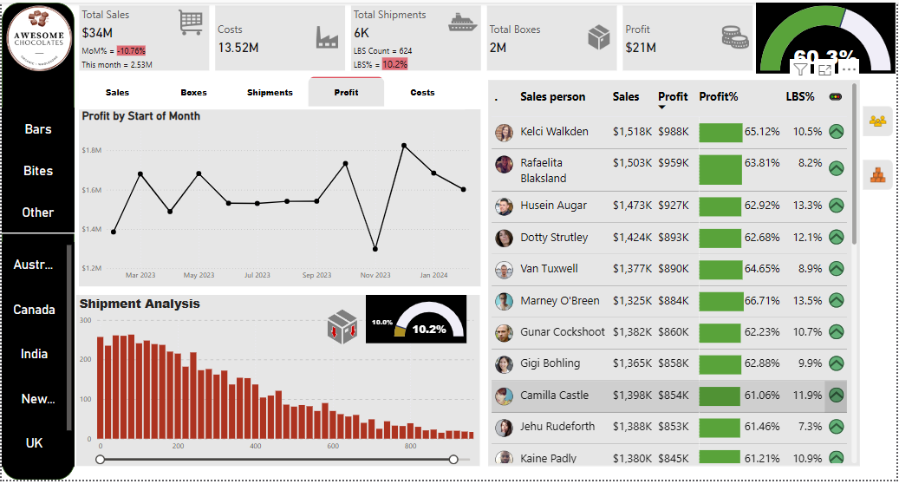

**Insights and Goals**

This sales analysis provides a clear understanding of various factors driving profitability, sales, and operational performance. Key insights and goals of the analysis include:

* **Tracking month-over-month changes** and identifying seasonal trends in sales, shipments, and profit.
* **Monitoring profitability targets** and identifying high- and low-performing products, regions, and salespeople.
* **Supporting strategic decision-making** by highlighting opportunities for sales growth, resource allocation, cost reduction, and pricing adjustments.

The dashboard serves as a strategic tool for managers and executives, providing them with the insights needed to drive business success.

**How to Use the Dashboard**

1. **Data Filters**:  
   Use the filters available on the left sidebar to isolate specific regions, product categories, or sales teams for a more focused analysis.
2. **Dashboard Tabs**:  
   Navigate between the dashboard tabs to explore different sections, including sales, profit, shipment, and cost analyses.
3. **Visual Indicators**:  
   Use the **profit target** and **LBS% indicators** to evaluate the performance of individual salespeople and identify areas with the highest impact.

These features make the dashboard interactive and highly customizable, allowing users to perform deep dives into the data.

**License**

This project is licensed under the **MIT License**. You are free to use, modify, and distribute this work, with appropriate attribution. For more details, please refer to the LICENSE file in the repository.